|  |
| --- |
| Name:  **Perera, L. Pasindu.** |
| Student Reference Number: **10568999** |



|  |  |  |
| --- | --- | --- |
| Module Code: ISAD253SL | Module Name: Databases | |
| Coursework Title: Hospital Management System | | |
| Deadline Date: 3rd January,2016 | | Member of staff responsible for coursework: Ms. Dileeka Alwis. |
| Programme: BSc (Honours) Software Engineering, Computer Networks, Computer Security. | | |
| Please note that University Academic Regulations are available under Rules and Regulations on the University website [www.plymouth.ac.uk/studenthandbook](http://www.plymouth.ac.uk/studenthandbook). | | |
| Group work: please list all names of all participants formally associated with this work and state whether the work was undertaken alone or as part of a team. Please note you may be required to identify individual responsibility for component parts.   |  |  | | --- | --- | | **Vidhanahena, I.P. Oshajith** | **10569207** | | **Perera, L. Pasindu (Team Leader)** | **10568999** | | **Chanuka, K. Imalsha** | **10569083** | | **Rathnayaka, R.M.K.S.B** | **10569071** | | **Wijesekara, J. Chanath Rajindra** | **10569206** |   ***We confirm that we have read and understood the Plymouth University regulations relating to Assessment Offences and that we are aware of the possible penalties for any breach of these regulations. We confirm that this is the independent work of the group.***  Signed on behalf of the group: | | |
| Individual assignment: ***I confirm that I have read and understood the Plymouth University regulations relating to Assessment Offences and that I am aware of the possible penalties for any breach of these regulations. I confirm that this is my own independent work.***  Signed: | | |
| Use of translation software: failure to declare that translation software or a similar writing aid has been used will be treated as an assessment offence.  I *have used/not used translation software.  If used, please state name of software………………………………………………………………… | | |
| **Overall mark _____% Assessors Initials ______ Date_________** | | |

**PROJECT REPORT**

**ISAD2543L-Databases**



**HOSPITAL MANAGEMNT SYSTEM**

**Project By: Catalyst Software Solutions**

**Team**

|  |  |
| --- | --- |
| **Name** | **Index** |
| Vidhanahena, I.P. Oshajith | 10569207 |
| Perera, L. Pasindu (Team Leader) | 10568999 |
| Chanuka, K. Imalsha | 10569083 |
| Rathnayaka, R.M.K.S.B. | 10569071 |
| Wijesekara, J. Chanath Rajindra | 10569206 |

**Abstract**

This is the Project Report document for the coursework of the module ISAD253SL (Databases) for the 2nd year 1st semester of the programmes BSc (Honours) Software Engineering, Computer Networks and Computer Security of the Plymouth University, U.K. which are conducted in National School of Business Management, Sri Lanka. The focus of the coursework of the module ISAD253SL is to analyse a real-time scenario with problematic environment and develop the best solution for the problematic scenario by applying the database design concepts and using a database development tool like SQL.

**Used Software Tools**

Several software tools were used to complete this project.

1. Microsoft SQL Server 2014

This software was used to create tables, add constraints, add triggers, stored procedures, user defined functions, to generate views which are necessary and to enter data into the database.

1. Microsoft Visio 2013

This software was the key software that we used to create digital Enhanced Entity Relationship Diagram and Relational Mapping Diagram.

1. Microsoft Word 2016

This software was used to create the Project Report for the course work.

1. Git

A git online repository was used to manage the work and also to secure the coursework content of each team member in case of emergency. GitHub was the Git client we used and the GitBash was the Git shell we used.

**Team and Workload**

|  |  |  |
| --- | --- | --- |
| Index Number | Name | Work Load |
| 10569207 | Vidhanahena, I.P. Oshajith |  |
| 10568999 | Perera, L. Pasindu (Team Leader) | EER, Stored Procedures |
| 10569083 | Chanuka, K. Imalsha |  |
| 10569071 | Rathnayaka, R.M.K.S.B. | Mapping |
| 10569206 | Wijesekara, J. Chanath Rajindra |  |

Introduction

Project Report Introduction

This document is a to describe requirements for a Hospital Management System which keeps records and maintain all the information regarding every aspect of a usual Hospital. This report also contains the constraints, assumptions and system implantation details and such information about the suggested system.

Project Introduction

This project covers a Hospital Management System which is developed by applying database development concepts and using SQL technology. The system is developed to keep records of each element of the hospital such as departments, rooms, staff and patients. The system is also capable of maintain the information about the mentioned elements and can manipulate data accordingly. The system will make most of the management processes of the Hospital autonomous and will reduces the workload of the staff and minimize the use of resources.

Scope

Project cover the most of the aspects of the Hospital such and Human Resources Management, Departments, Room allocation, Patient Examination, Patient Admitting, Patient Discharging, Treatments, Surgeries and Drug Issuing.

References

General Description

Scenario

**Organization – City Central Hospital**

**Specialties - Multi-Specialty Hospital**

**Identified Elements – Departments, rooms, doctors, nurses, attendants, other staff, patients, Operations, Check-ups, Drugs, Treatments.**

**Scenario Description**

**Departments**

City Central Hospital has few department like Orthopaedic, Pathology, Emergency, Dental, Gynaecology, Anaesthetics, I.C.U., Blood Bank, Operation Theatre, Laboratory, M.R.I., Neurology, Cardiology, Cancer Department, Corpse, etc.

**OPD**

Hospital has a OPD (Outpatient Department) where patients visits for check-ups with doctors.

**Patients**

Information about the patient is collected when patient arrives at the hospital.

**Non-Admitting Patients**

An Entry card for a patient is generated and sent to doctor.

Every patient has unique patient number.

**Admitting Patients**

Patient can choose a private of general room when admitting according to his/her preferring.

Before admitting patient has to fulfil some formalities such as room charges and etc.

When admitted patient number, payment method, advanced payment condition, diagnosis, admitted date, treatment and such information are recorded.

When discharging, patient has to go through some formalities like balance charges, test charges, operation charges, doctor charges and etc.

When patient is discharged, entry is recorded in the database with patient number, treatment given, treatment advice, payment made, mode of payment date of discharged and etc.

**Regular Patients**

Details about regular patients like visit, diagnosis, treatment, medicine recommended and status of treatment should also be recorded. There can be multiple entries of one patient for patient’s each visit. Operation details such as patient number, date of admission, date of operation, number of the doctor who conducted the operation, number of the operation theatre in which operation was carried out, type of operation, patient’s condition before and after operation and treatment advice, should also be stored in the database, if the patient face any operation in the hospital.

**Doctors**

Each doctor’s information should also be included in the database. Doctors are assigned to Departments. The database should store doctors’ data like name, qualification, address, phone number and etc. There are two types of the doctors in the City Central Hospital.

* Regular Doctors who work in the hospital and come to the hospital daily. Database should store following information about Regular Doctors. Pre-defined salary, date of joining and etc.
* Call on Doctors who are called by the hospital if the concerned doctor is not available or when additional doctors are required. Database must have information about Call on Doctors like fees per call, payment due and etc.

**Rooms**

Database should keep records like room number, room type (general or private), status, if occupied then patient number, patient name, charges per day and etc. Room number should be unique and room type can only be ‘G’ for General Room or ‘P’ for Private Room and status can only be ‘Y’ or ‘N’.

**Drugs, Treatments and Operations**

Basic details about drugs, treatments and operations should also be included in the database separately. And also, the database should be aware of the details about customer payments whenever they prescribe medicine, undergo operations, admit in the hospital and discharge from the hospital etc.

**Other Hospital Employees**

Information about the other hospital staff like nurses, attendants, laboratory staff should be included in the database.

Requirements

Functional Requirements

Non – Functional Requirements

Users

The main user of this system will be System Administrator, who is literate with computers and can use a SQL database correctly.

Hospital management can also have privileges to DELETE, UPDATE or ADD records to employee tables, department, room and drugs tables.

The doctors and nurses have certain privileges and attendant can also use the system with under several conditions.

Assumptions

All the employees are assigned to departments. One employee only belongs in a certain department.

All the employees in the hospital are doctors or nurses or attendants or other staff. There are no other employees in the organization.

All the employees have a employee_id with different prefixes for each type of employees.

One Check-up can have only one treatment.

Patient can admit in the hospital only after a Check-up.

Treatments and drugs are issued only after a Check-up.

One doctor engages in many operations.

Many doctors can engage in one operation.

Admitted patient can also go to another Check-up.

System Design

Identifying Entities

When analysing case study, we can identify several entities.

* + - Department
    - Rooms
    - Employee
    - Patient
    - Check-ups
    - Treatments
    - Drugs
    - Patient admission
    - Operation
    - Discharge record
    - Payment

Further we can divide Rooms, Employee and Patient entities into sub entities.

Employee

* + Nurse
  + Attendant
  + Doctor
  + Other Staff

Patient

* Regular patient
* Admitted patient

Rooms

* General rooms
* Private rooms

Further we can divide Doctor sub entity in to 2 sub entities.

Doctor

* + Regular doctor
  + Call on doctor

Identifying Attributes for pre-identified identities

1. **department**

(department_id, department_name, location, facilities)

1. **rooms**

(room_no, type, status)

* 1. **general_rooms**
  2. **private_rooms**

1. **employee**

(employee_id, name, gender, address, NIC_no, phone_no, employee_type, department_id)

* 1. **nurse**

(nurse_id, qualification)

* 1. **attendant**

(employee_id)

* 1. **other_staff**

(employee_id)

* 1. **doctor**

(employee_id, specialized_field)

* + 1. **regular_doctor**

(employee_id, basic_salary, date_of_joining)

* + 1. **callon_doctor**

(employee_id, call_on_fee, payment_due)

1. **patient**

(patient_id, first_name, last_name, entry_date, dob, gender, address, phone_number)

1. **regular_patient**

(patient_id)

1. **admitted_patient**

(patient_id)

1. **checkups**

(checkup_id, operation_id, date, check_up_fee, diagnosis, patient_condition, patient_id, employee_id)

1. **treatments**

(treatment_id,type,description, checkup_id)

1. **drugs**

(drug_id,price,Alternative_drug,name,dose_description, checkup_id)

1. **patient_admisson**

(admission_id, advance_payment, payment_method, initial_condition, guardian_name, guardian_contact_no, checkup_id, admission_date)

1. **operation**

(operation_id, operation_type, operation_date, treatment_advice, description, caution_level, admission_id, doctor_id)

1. **discharge_record**

(discharge_id, fee, treatment_advice, discharge_condition, discharge_date, admission_id)

1. **payment**

(bill_id,total,description,patient_id)

ER and EER Diagrams

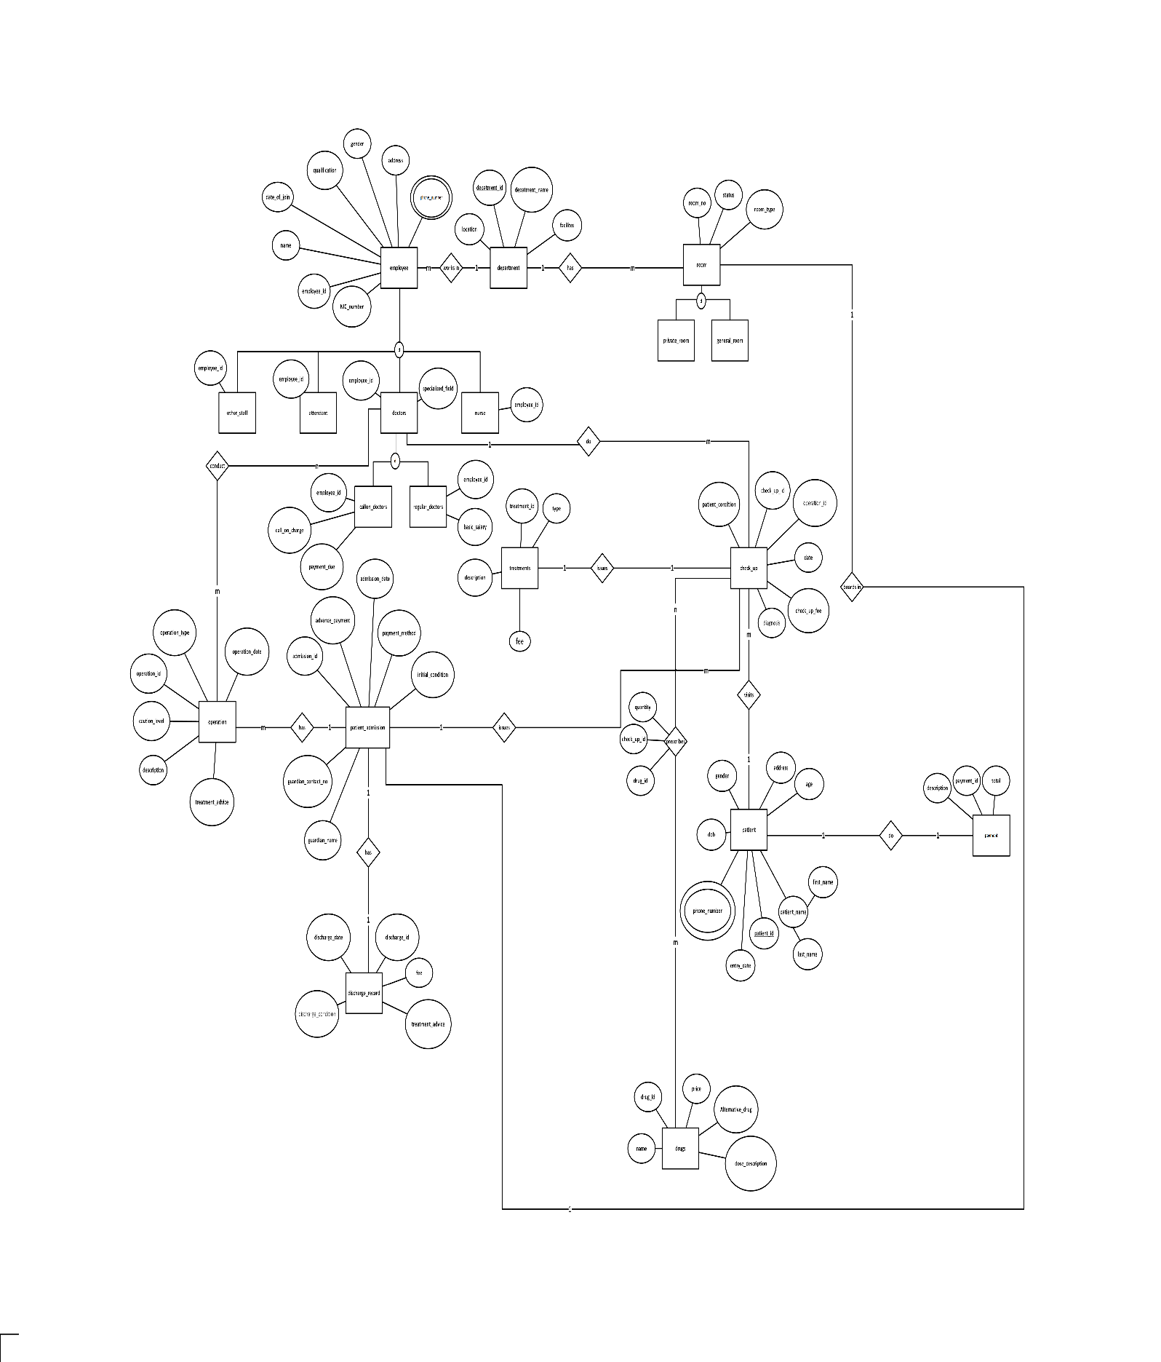

**Here is a enlarged clear version of the above EER diagram of the database.** [**Enlarged-EER Diagram(PDF)**](EER.pdf)

Relational Mapping

**Here is a enlarged clear version of the above Relational Mapping diagram of the database.** [**Relational Mapping Diagram(PDF)**](mapping.pdf)

Normalization

1st Normalization Form

2nd Normalization Form

3rd Normalization Form

SQL Development

Creating tables

Constraints

Stored Procedures

Triggers

User Defined Functions

Data Entry

Views